# Azure Bootstrap

## Linux Based Virtual Machines:

* Ubuntu (14.04, 16.04 , 18.04)
* RHEL (7.7 and above)
* Cent OS (7.7 and above)

## Use Bootstrap commands to deploy Applications in Virtual Machine:

* Use bootstrap commands to deploy the applications like Apache, Tomcat, MySQL, and PostgreSQL while deploying the Virtual Machine.
* Copy and paste the bootstrap commands in cloud init as shown in the below figure.

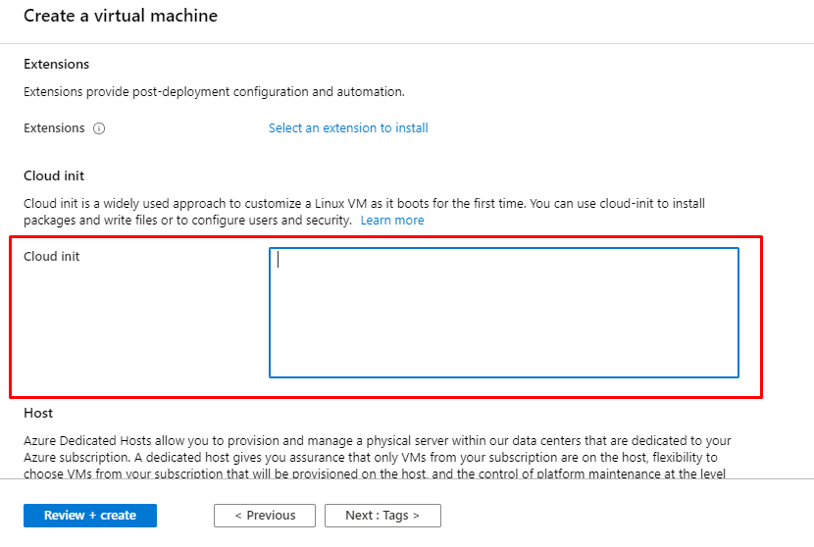

## Commands to deploy applications in Ubuntu (14.04, 16.04, 18.04)

### Apache:

# apt-get update

# apt-get install apache2 -y

# systemctl start apache2

### Apache Tomcat:

# apt-get update

# apt-get install java

# apt-get install tomcat8 -y

# systemctl start tomcat8

### MySQL:

# apt-get update

#apt-get install mysql –y

#systemctl start mysql

### PostgreSQL:

# apt-get update

# apt-get –y install postgresql

# systemctl start postgresql